ASSIGNMENT 4

Distance Detection Using 5 November 2022

Ultrasonic Sensor Assignment

Date

Student Name Kanimozhi M

Student Roll Number 710019106020

Maximum Marks 2 Marks

WOKWI CODE:

#include <WiFi.h>//library for wifi

#include <PubSubClient.h>//library for MQtt void callback(char* subscribetopic, byte* payload, unsigned int payloadLength);

//-------credentials of IBM Accounts------

#define ORG "0kflrb"//IBM ORGANITION ID

#define DEVICE_TYPE "kanimonidevice"//Device type mentioned in ibm watson IOT Platform

#define DEVICE_ID "7890"//Device ID mentioned in ibm watson IOT Platform

#define TOKEN "12345678" //Token String data3; float dist;

//-------- Customise the above values -------- char server[] = ORG ".messaging.internetofthings.ibmcloud.com";// Server Name

char publishTopic[] = "iot-2/evt/Data/fmt/json";// topic name and type of event perform and format in which data to be send

char subscribetopic[] = "iot-2/cmd/test/fmt/String";// cmd REPRESENT command type AND COMMAND IS TEST OF FORMAT STRING

char authMethod[] = "use-token-auth";// authentication method char token[] = TOKEN; char clientId[] = "d:" ORG ":" DEVICE_TYPE ":" DEVICE_ID;//client id

//-----------------------------------------

WiFiClient wifiClient; // creating the instance for wificlient

PubSubClient client(server, 1883, callback ,wifiClient); //calling the predefined client id by passing parameter like server id,portand wificredential int LED = 4;

int trig = 5;

int echo = 18; void setup()

{

Serial.begin(115200); pinMode(trig,OUTPUT); pinMode(echo,INPUT); pinMode(LED, OUTPUT);

delay(10); wificonnect(); mqttconnect();

}

void loop()// Recursive Function

{

digitalWrite(trig,LOW); digitalWrite(trig,HIGH); delayMicroseconds(10); digitalWrite(trig,LOW); float dur = pulseIn(echo,HIGH); float dist = (dur * 0.0343)/2;

Serial.print ("Distancein cm");

Serial.println(dist); PublishData(dist); delay(1000); if (!client.loop()) {

mqttconnect();

}

} /*.....................................retrieving to Cloud...............................*/

void PublishData(float dist) { mqttconnect();//function call for connecting to ibm

/*

creating the String in in form JSon to update the data to ibm cloud

*/ String object; if (dist <100)

{

digitalWrite(LED,HIGH); Serial.println("object is near"); object = "Near";

}

else

{

digitalWrite(LED,LOW); Serial.println("no object found"); object = "No";

}

String payload = "{\"distance\":"; payload += dist; payload += "," "\"object\":\""; payload += object; payload += "\"}"; Serial.print("Sending payload: ");

Serial.println(payload);

if (client.publish(publishTopic, (char*) payload.c_str())) {

Serial.println("Publish ok");// if it sucessfully upload data on the cloud then it will print publish ok in Serial monitor or else it will print publish failed

} else {

Serial.println("Publish failed");

}

}

void mqttconnect() {

if (!client.connected()) {

Serial.print("Reconnecting client to "); Serial.println(server); while (!!!client.connect(clientId, authMethod, token)) { Serial.print("."); delay(500);

}

initManagedDevice();

Serial.println();

}

}

void wificonnect() //function defination for wificonnect

{

Serial.println();

Serial.print("Connecting to ");

**WOKWI LINK:** <https://wokwi.com/projects/348053637539299922>

WOKWI CIRCUIT DIAGRAM AND WOKWI OUTPUT:

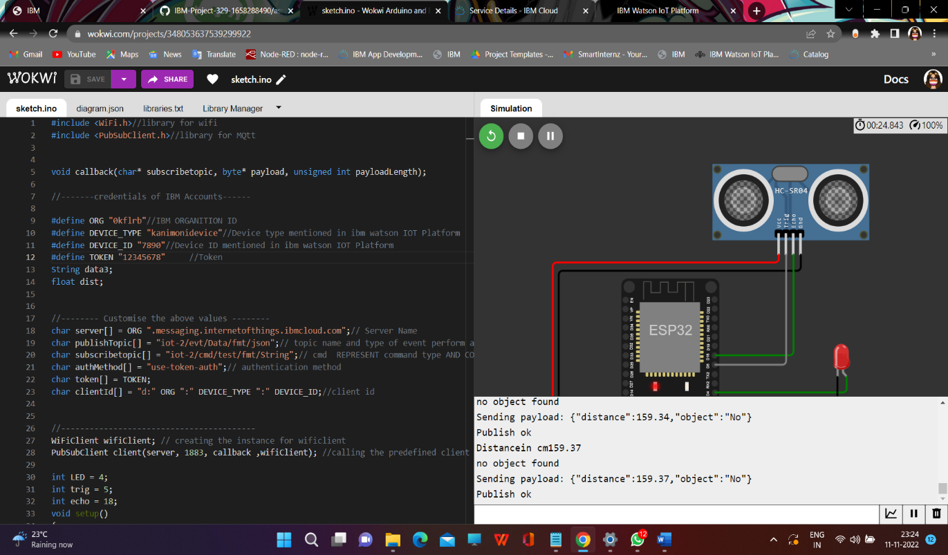

IBM WATSON OUTPUT:

